SideMenu SA
1、Introduction
SideMenu is a frame that helps to switch from one scene to another scene by touching a button or sliding left or right.

Examples:
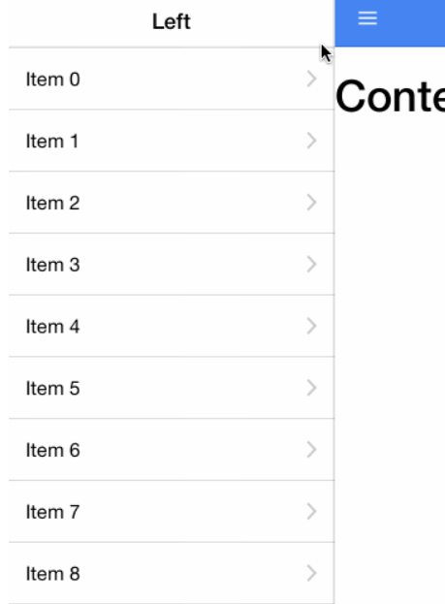
- Stockholders
Through our discussion, we think the students and the app developers are the stockholders. For students, they can learn from SideMenu, knowing how it is designed and use it in practical program. As for app developers, they directly use the frame in the app or modify it to make it perfect.
- Context View
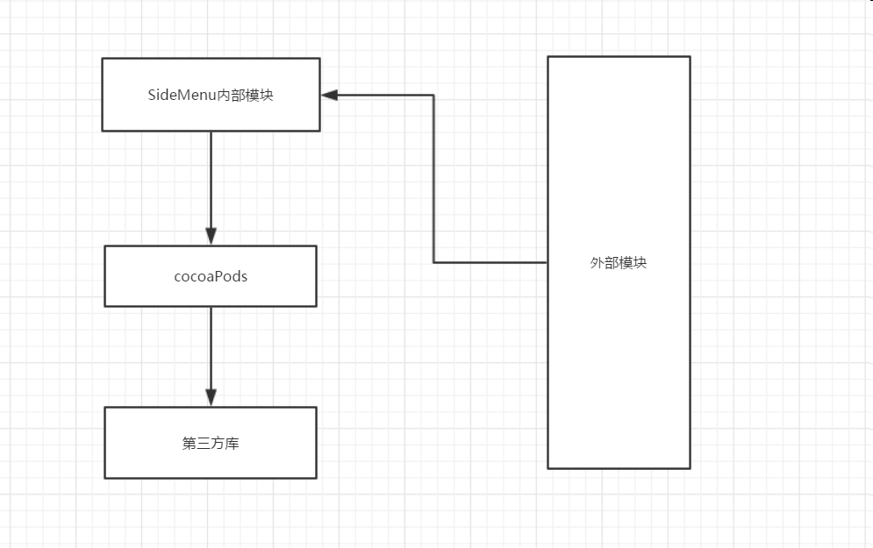

External Module：that is the app which use SideMenu
Internal Module：this is the SideMenu frame, in this module it shows how SideMenu is implemented
CocosPods: CocoaPods is a third class library management tool for OS X and iOS. With the CocoaPods tool, we can add a dependency library called "Pods" to the project and easily manage its version.
Third Class: this is SideMenu dependency library
(to be continued)

- Use case View
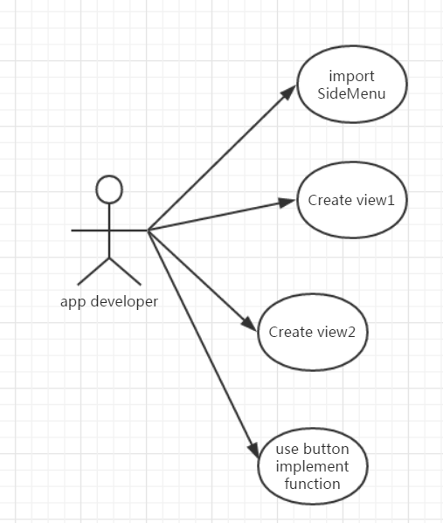
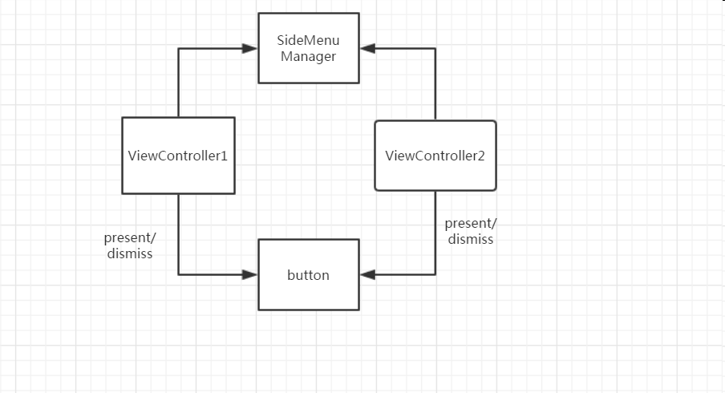

- Logic View
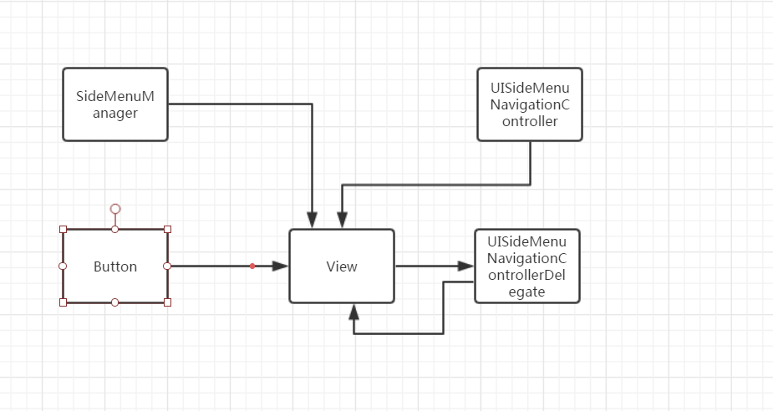
UISideMenuNavigationController
This class mainly controls the view’s size and where the view show up.

UISideMenuNavigationControllerDelegate
To receive notifications when a menu is displayed from a view controller, have it adhere to the UISideMenuNavigationController
-Delegeate protocol. This class determine which view to show up and which view dismiss.

SideMenuManager
This class is the key to SideMenu. It manages the SideMenu Framework.
Advanced
This mainly shows how develop SideMenu on the base of it.
For simplicity, SideMenuManager.default serves as the primary instance as most projects will only need one menu across all screens. If you need to show a different SideMenu, such as from a modal view controller presented from a previous SideMenu, do the following:
- Declare a variable containing your custom SideMenuManager instance. You may want it to define it globally and configure it in your app delegate if menus will be used on multiple screens
- Setup and display menus with your custom instance the same as you would with the SideMenuManager.default instance.
- If using Storyboards, subclass your instance of UISideMenuNavigationController and set its sideMenuManager property to your custom instance. This must be done before viewDidLoad is called:

